Statistics and Probability Project Rubric
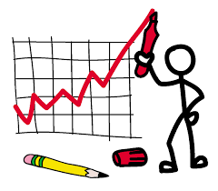
__________8pts Project is neat, colorful and bound in a book. Use a separate page for each item.
__________10pts All Work Shown in the Project. Be sure to show all calculations in a neat and organized manner. Also, include labels for each calculation.
__________10pts A table, with all the data present, that shows the individuals, their relationship to you, and age.
__________10pts A stem-and-leaf plot that shows all the ages in your set of data.
__________10pts A stem-and-leaf plot that shows all the ages of males and females "back-to-back".
__________10pts A circle graph, with percent labels, that shows the amount of individuals in the age categories below. babies (0 - 1); children (2 - 12); teens (13 - 19); young adults (20 - 29); adults (30 - 69); seniors (70 +)
Use a separate page for each item.
__________5pts 1. a. Mean, median, and mode age for all data.
__________5pts b.Find quartiles and draw a box-and-whisker plot for all data.
__________5pts 2. a. Mean, median, and mode age for all males.
__________5pts b.Find quartiles and draw a box-and-whisker plot for all males.
__________5pts 3. a. Mean, median, and mode age for all females.
__________5pts b.Find quartiles and draw a box-and-whisker plot for all females.
__________12pts Probability/Counting Questions Page (graded for accuracy)
